**Button Design**

**EXAMPLE : 1**

styles.xml

<resources>  
 *<!-- Base application theme. -->* <style name="AppTheme" parent="Theme.AppCompat.Light.DarkActionBar">  
 *<!-- Customize your theme here. -->* <item name="colorPrimary">@color/colorPrimary</item>  
 <item name="colorPrimaryDark">@color/colorPrimaryDark</item>  
 <item name="colorAccent">@color/colorAccent</item>  
 </style>  
  
 <style name="MyButton" parent="Theme.AppCompat.Light">  
 <item name="colorControlHighlight">#673AB7</item>  
 <item name="colorButtonNormal">#E91E63</item>  
 </style>  
</resources>

activity_main.xml

*<?*xml version="1.0" encoding="utf-8"*?>*<LinearLayout  
 xmlns:android="http://schemas.android.com/apk/res/android"  
 xmlns:app="http://schemas.android.com/apk/res-auto"  
 xmlns:tools="http://schemas.android.com/tools"  
 android:layout_width="match_parent"  
 android:layout_height="match_parent"  
 android:layout_margin="10dp"  
 android:gravity="center"  
 android:orientation="vertical">  
  
 <Button  
 android:layout_width="wrap_content"  
 android:layout_height="wrap_content"  
 android:text="Button"  
 android:theme="@style/MyButton"/>  
</LinearLayout>

Unpressed Button

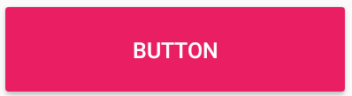

Pressed Button

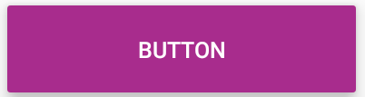

**EXAMPLE : 2**

styles.xml

<resources>  
 *<!-- Base application theme. -->* <style name="AppTheme" parent="Theme.AppCompat.Light.DarkActionBar">  
 *<!-- Customize your theme here. -->* <item name="colorPrimary">@color/colorPrimary</item>  
 <item name="colorPrimaryDark">@color/colorPrimaryDark</item>  
 <item name="colorAccent">@color/colorAccent</item>  
 </style>  
  
 <style name="MyButton" parent="Theme.AppCompat.Light">  
 <item name="colorControlHighlight">#E91E63</item>  
 </style>  
</resources>

activity_main.xml

*<?*xml version="1.0" encoding="utf-8"*?>*<LinearLayout  
 xmlns:android="http://schemas.android.com/apk/res/android"  
 xmlns:app="http://schemas.android.com/apk/res-auto"  
 xmlns:tools="http://schemas.android.com/tools"  
 android:layout_width="match_parent"  
 android:layout_height="match_parent"  
 android:layout_margin="10dp"  
 android:gravity="center"  
 android:orientation="vertical">  
  
 <Button  
 android:layout_width="wrap_content"  
 android:layout_height="wrap_content"  
 android:text="Button"  
 android:theme="@style/MyButton"  
 style="@style/Widget.AppCompat.Button.Borderless"/>  
</LinearLayout>

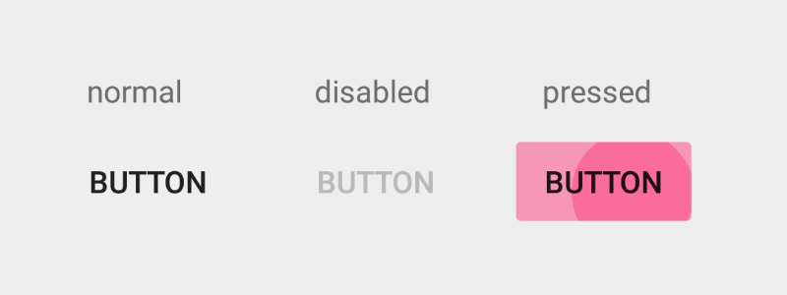

**EXAMPLE : 3**

styles.xml

<resources>  
 *<!-- Base application theme. -->* <style name="AppTheme" parent="Theme.AppCompat.Light.DarkActionBar">  
 *<!-- Customize your theme here. -->* <item name="colorPrimary">@color/colorPrimary</item>  
 <item name="colorPrimaryDark">@color/colorPrimaryDark</item>  
 <item name="colorAccent">@color/colorAccent</item>  
 </style>  
  
 <style name="MyButton" parent="Theme.AppCompat.Light">  
 <item name="colorControlHighlight">#673AB7</item>  
 <item name="colorButtonNormal">#E91E63</item>  
 </style>  
</resources>

activity_main.xml

*<?*xml version="1.0" encoding="utf-8"*?>*<LinearLayout  
 xmlns:android="http://schemas.android.com/apk/res/android"  
 xmlns:app="http://schemas.android.com/apk/res-auto"  
 xmlns:tools="http://schemas.android.com/tools"  
 android:layout_width="match_parent"  
 android:layout_height="match_parent"  
 android:layout_margin="10dp"  
 android:gravity="center"  
 android:orientation="vertical">  
  
 <Button  
 android:layout_width="200dp"  
 android:layout_height="60dp"  
 android:drawableLeft="@drawable/ic_star_border_black_24dp"  
 android:drawableStart="@drawable/ic_star_border_black_24dp"  
 android:text="LIKE"  
 android:theme="@style/MyButton"/>  
</LinearLayout>

Unpressed Button

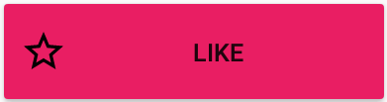

Pressed Button

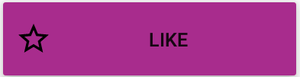

**EXAMPLE : 4 ( with ripple effect )**

Create a file called button_background.xml inside Drawable folder.

*<?*xml version="1.0" encoding="utf-8"*?>*<ripple  
 xmlns:android="http://schemas.android.com/apk/res/android"  
 xmlns:tools="http://schemas.android.com/tools"  
 android:color="#0dafdc"  
 tools:targetApi="lollipop">  
 <item>  
 <shape android:shape="rectangle">  
 <corners android:radius="100dp"/>  
 <gradient android:angle="90"  
 android:startColor="#285FBA"  
 android:endColor="#7535AD">  
 </gradient>  
 </shape>  
 </item>  
</ripple>

activity_main.xml

*<?*xml version="1.0" encoding="utf-8"*?>*<LinearLayout xmlns:android="http://schemas.android.com/apk/res/android"  
 xmlns:app="http://schemas.android.com/apk/res-auto"  
 xmlns:tools="http://schemas.android.com/tools"  
 android:layout_width="match_parent"  
 android:layout_height="match_parent"  
 android:orientation="vertical"  
 android:gravity="center"  
 tools:context=".MainActivity">  
  
 <Button  
 android:id="@+id/first_button"  
 android:layout_width="200dp"  
 android:layout_height="wrap_content"  
 android:layout_marginTop="10dp"  
 android:background="@drawable/button_background"  
 android:textSize="20sp"  
 android:text="FIRST"  
 android:textColor="@android:color/white"/>  
  
 <Button  
 android:id="@+id/second_button"  
 android:layout_width="200dp"  
 android:layout_height="wrap_content"  
 android:layout_marginTop="10dp"  
 android:background="@drawable/button_background"  
 android:textSize="20sp"  
 android:text="SECOND"  
 android:textColor="@android:color/white"/>  
  
 <Button  
 android:id="@+id/third_button"  
 android:layout_width="200dp"  
 android:layout_height="wrap_content"  
 android:layout_marginTop="10dp"  
 android:background="@drawable/button_background"  
 android:textSize="20sp"  
 android:text="THIRD"  
 android:textColor="@android:color/white"/>  
</LinearLayout>

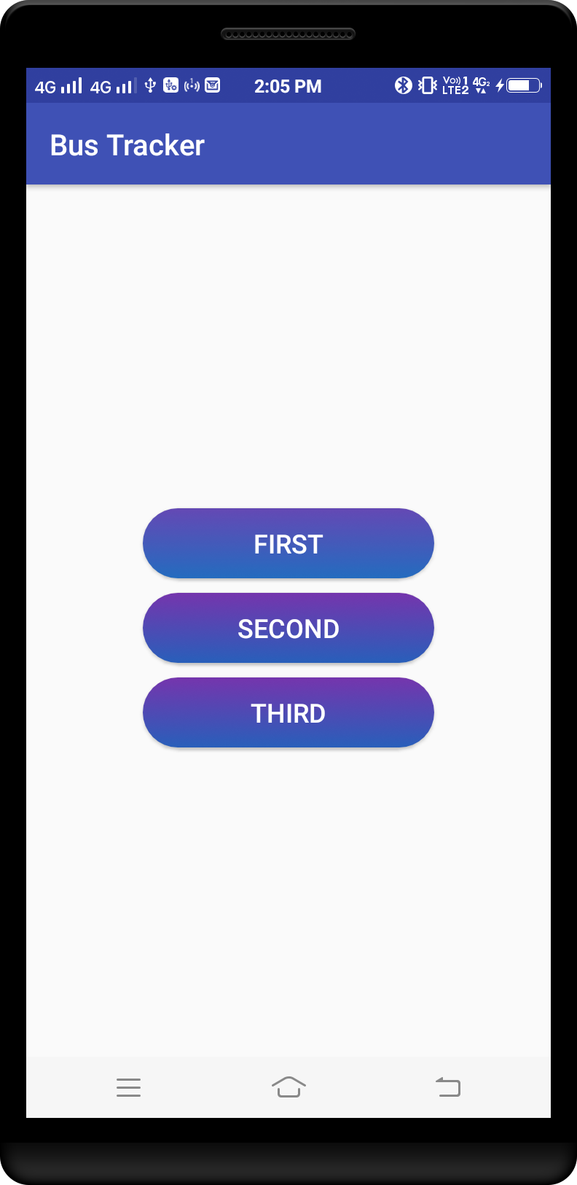

*<?***xml version="1.0" encoding="utf-8"***?>*<**ScrollView  
 xmlns:android="http://schemas.android.com/apk/res/android"  
 xmlns:app="http://schemas.android.com/apk/res-auto"  
 android:layout_width="match_parent"  
 android:layout_height="match_parent"  
 android:layout_gravity="center_horizontal"  
 android:background="#FFFFFF"  
 android:gravity="center_horizontal"**>  
  
 <**LinearLayout  
 android:layout_width="match_parent"  
 android:layout_height="wrap_content"  
 android:layout_gravity="bottom"  
 android:gravity="bottom"  
 android:orientation="vertical"**>  
  
 <**TableLayout  
 android:layout_width="match_parent"  
 android:layout_height="match_parent"**>  
  
 <**TableRow  
 android:layout_width="match_parent"  
 android:layout_height="wrap_content"  
 android:orientation="horizontal"**>  
   
 <**Button  
 android:id="@+id/setup_macroSavebtn"  
 android:layout_width="0dp"  
 android:layout_height="wrap_content"  
 android:layout_gravity="left"  
 android:layout_weight="1"  
 android:onClick="onSaveButtonClick"  
 android:text="Save"**/>  
  
 <**Button  
 android:id="@+id/setup_macroCancelbtn"  
 android:layout_width="0dp"  
 android:layout_height="wrap_content"  
 android:layout_gravity="right"  
 android:layout_weight="1"  
 android:onClick="onCancelButtonClick"  
 android:text="Cancel"**/>  
 </**TableRow**>  
  
 <**TableRow android:gravity="center"**>  
  
 <**Button  
 android:layout_width="wrap_content"  
 android:layout_height="wrap_content"  
 android:background="@android:color/holo_green_dark"  
 android:text="BUTTON 1"** />  
  
 <**Button  
 android:layout_width="wrap_content"  
 android:layout_height="wrap_content"  
 android:background="@android:color/holo_red_dark"  
 android:text="BUTTON 2"** />  
 </**TableRow**>  
  
 <**TableRow  
 android:layout_width="fill_parent"  
 android:layout_height="wrap_content"**>  
  
 <**Button  
 android:layout_width="0dp"  
 android:layout_height="match_parent"  
 android:layout_weight="0.5"  
 android:background="@android:color/holo_green_dark"  
 android:text="BUTTON 1"** />  
  
 <**Button  
 android:layout_width="0dp"  
 android:layout_height="match_parent"  
 android:layout_weight="0.5"  
 android:background="@android:color/holo_red_dark"  
 android:text="BUTTON 2"** />  
  
 <**Button  
 android:layout_width="0dp"  
 android:layout_height="match_parent"  
 android:layout_weight="0.5"  
 android:background="@android:color/holo_green_dark"  
 android:text="BUTTON 3"** />  
  
 <**Button  
 android:layout_width="0dp"  
 android:layout_height="match_parent"  
 android:layout_weight="0.5"  
 android:background="@android:color/holo_red_dark"  
 android:text="BUTTON 4"** />  
  
 <**Button  
 android:layout_width="0dp"  
 android:layout_height="match_parent"  
 android:layout_weight="0.5"  
 android:background="@android:color/holo_green_dark"  
 android:text="BUTTON 5"** />  
 </**TableRow**>  
 </**TableLayout**>  
 </**LinearLayout**>  
</**ScrollView**>

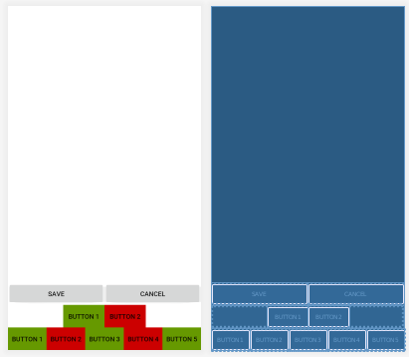

*<?***xml version="1.0" encoding="utf-8"***?>*<**RelativeLayout xmlns:android="http://schemas.android.com/apk/res/android"  
 android:id="@+id/RelativeLayout1"  
 android:layout_width="match_parent"  
 android:layout_height="match_parent"  
 android:orientation="vertical"** >  
  
 <**LinearLayout  
 android:layout_width="match_parent"  
 android:layout_height="wrap_content"  
 android:layout_alignParentRight="true"  
 android:layout_alignParentLeft="true"  
 android:layout_alignParentBottom="true"** >  
  
 <**Button  
 android:id="@+id/button1"  
 android:layout_width="0dp"  
 android:layout_height="wrap_content"  
 android:layout_weight="1"  
 android:layout_marginRight="2dp"  
 android:text="Modify"** />  
  
 <**Button  
 android:id="@+id/button2"  
 android:layout_width="0dp"  
 android:layout_height="wrap_content"  
 android:layout_weight="1"  
 android:layout_marginRight="2dp"  
 android:text="Cancle"** />  
  
 </**LinearLayout**>  
  
</**RelativeLayout**>

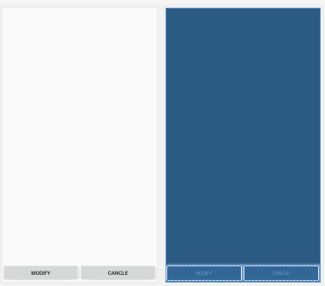

Ripple effect button

colors.xml

*<?***xml version="1.0" encoding="utf-8"***?>*<**resources**>  
 <**color name="colorPrimary"**>#3F51B5</**color**>  
 <**color name="colorPrimaryDark"**>#303F9F</**color**>  
 <**color name="colorAccent"**>#FF4081</**color**>  
 <**color name="white"**>#ffffffff</**color**>  
 <**color name="black"**>#000000</**color**>  
 <**color name="yellow"**>#fff5f504</**color**>  
 <**color name="red"**>#B71C1C</**color**>  
</**resources**>

styles.xml

<**resources**>  
  
 *<!-- Base application theme. -->* <**style name="AppTheme" parent="@style/Theme.AppCompat.NoActionBar"**>  
 <**item name="android:windowFullscreen"**>true</**item**>  
 <**item name="colorAccent"**>@color/colorAccent</**item**>  
 <**item name="colorPrimary"**>@color/colorPrimary</**item**>  
 <**item name="colorPrimaryDark"**>@color/colorPrimaryDark</**item**>  
 </**style**>  
  
 <**style name="ButtonLogin" parent="@style/Theme.AppCompat.Light"**>  
 <**item name="android:textColor"**>@color/white</**item**>  
 <**item name="colorButtonNormal"**>@color/colorAccent</**item**>  
 <**item name="colorControlHighlight"**>@color/yellow</**item**>  
 </**style**>  
  
 <**style name="ButtonSignUp" parent="@style/Theme.AppCompat.Light"**>  
 <**item name="android:textColor"**>@color/white</**item**>  
 <**item name="colorButtonNormal"**>@color/colorPrimary</**item**>  
 <**item name="colorControlHighlight"**>@color/yellow</**item**>  
 </**style**>  
  
 <**style name="ButtonRegister" parent="@style/Theme.AppCompat.Light"**>  
 <**item name="android:textColor"**>@android:color/black</**item**>  
 <**item name="colorButtonNormal"**>@color/yellow</**item**>  
 <**item name="colorControlHighlight"**>@color/colorPrimary</**item**>  
 </**style**>  
</**resources**>

btn_login.xml

*<?***xml version="1.0" encoding="utf-8"***?>*<**ripple  
 xmlns:android="http://schemas.android.com/apk/res/android"  
 android:color="#fff5f504"**>  
  
 <**item**>  
 <**shape android:shape="rectangle"**>  
 <**solid android:color="#FF4081"**/>  
 <**stroke android:color="#FF4081"**/>  
 <**corners android:radius="7dp"**/>  
 </**shape**>  
 </**item**>  
</**ripple**>

btn_signup.xml

*<?***xml version="1.0" encoding="utf-8"***?>*<**ripple  
 xmlns:android="http://schemas.android.com/apk/res/android"  
 android:color="#fff5f504"**>  
  
 <**item**>  
 <**shape android:shape="rectangle"**>  
 <**solid android:color="#3F51B5"**/>  
 <**stroke android:color="#3F51B5"**/>  
 <**corners android:radius="7dp"**/>  
 </**shape**>  
 </**item**>  
</**ripple**>

activity_main.xml

*<?***xml version="1.0" encoding="utf-8"***?>*<**LinearLayout  
 xmlns:android="http://schemas.android.com/apk/res/android"  
 xmlns:app="http://schemas.android.com/apk/res-auto"  
 android:id="@+id/activity_main"  
 android:layout_width="fill_parent"  
 android:layout_height="fill_parent"  
 android:layout_gravity="center_horizontal"  
 android:background="@drawable/diego_ph"  
 android:orientation="vertical"  
 android:padding="20dp"**>  
  
 <**Button  
 android:id="@+id/login"  
 android:layout_width="match_parent"  
 android:layout_height="wrap_content"  
 android:layout_marginBottom="20dip"  
 android:text="Login"  
 android:theme="@style/ButtonLogin"  
 android:background="@drawable/btn_login"**/>  
  
 <**Button  
 android:id="@+id/signUp"  
 android:layout_width="match_parent"  
 android:layout_height="wrap_content"  
 android:text="Sign Up"  
 android:theme="@style/ButtonSignUp"  
 android:background="@drawable/btn_signup"**/>  
</**LinearLayout**>

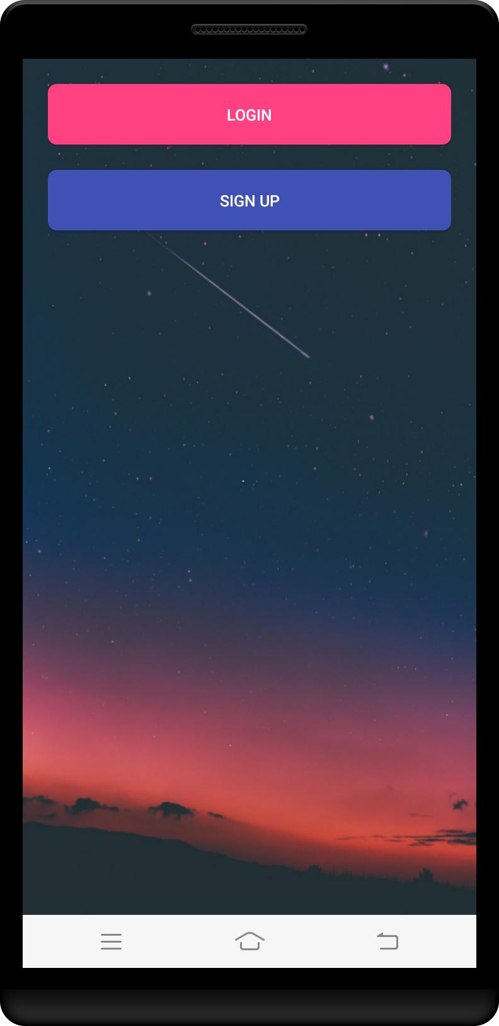

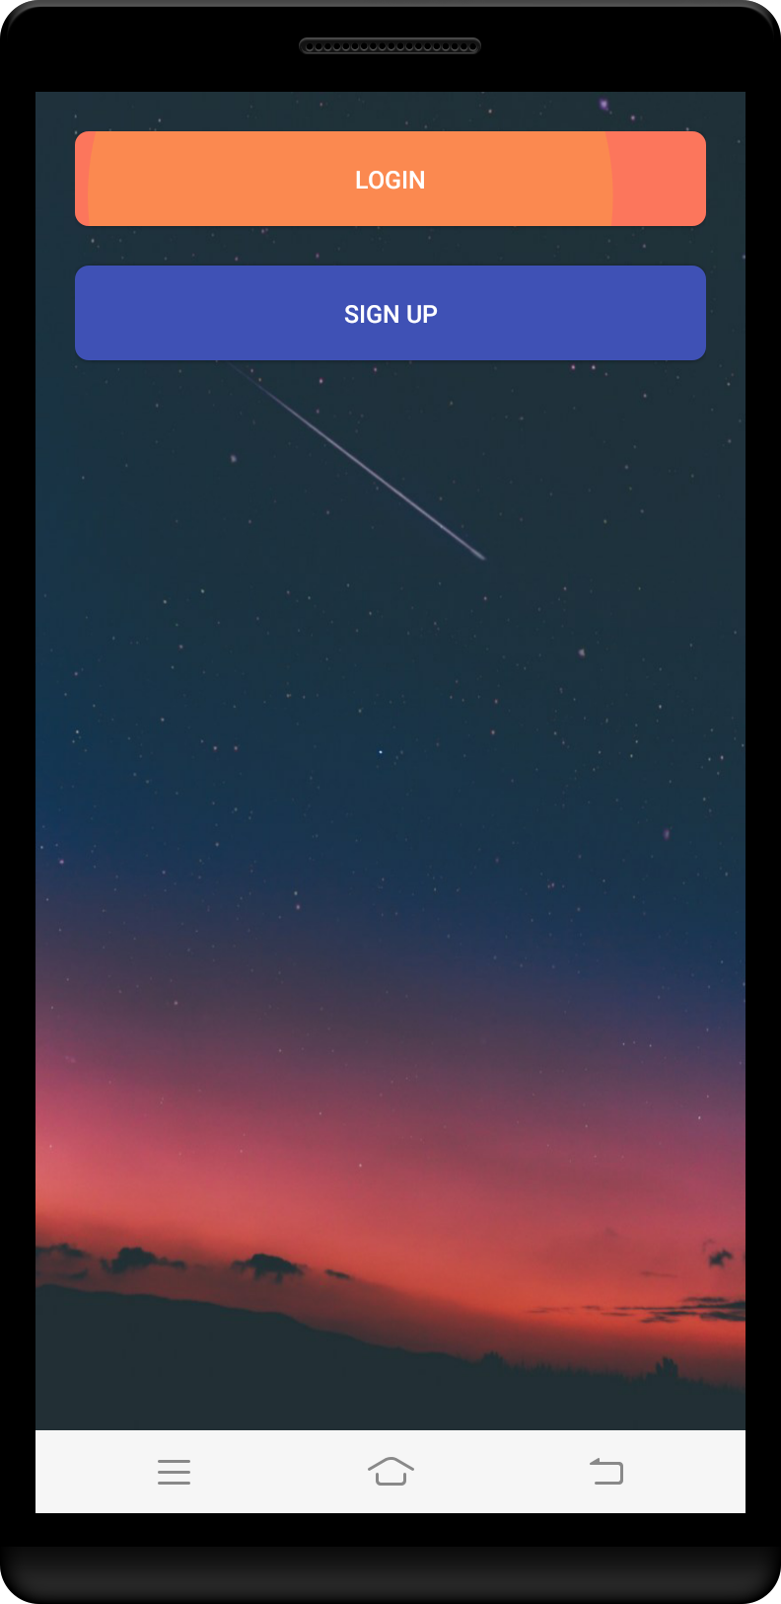

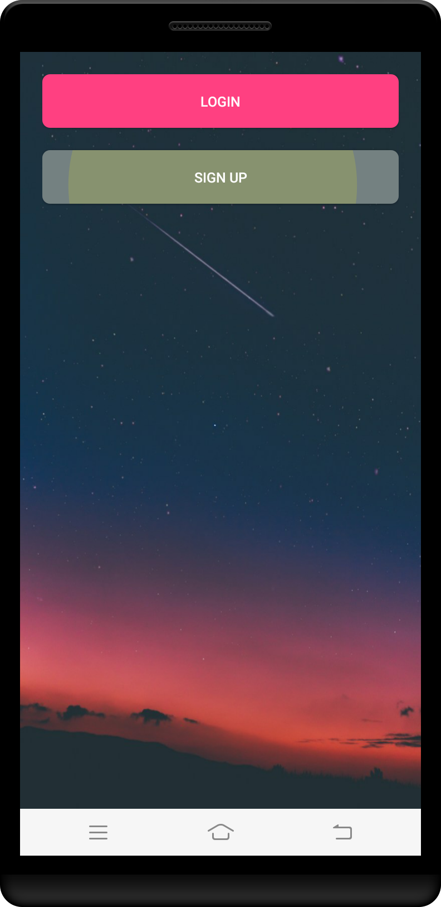

<https://stackoverflow.com/questions/54624722/how-to-achieve-android-button-animation-with-text-blurred-and-shadow>